**The Marketplace Website**

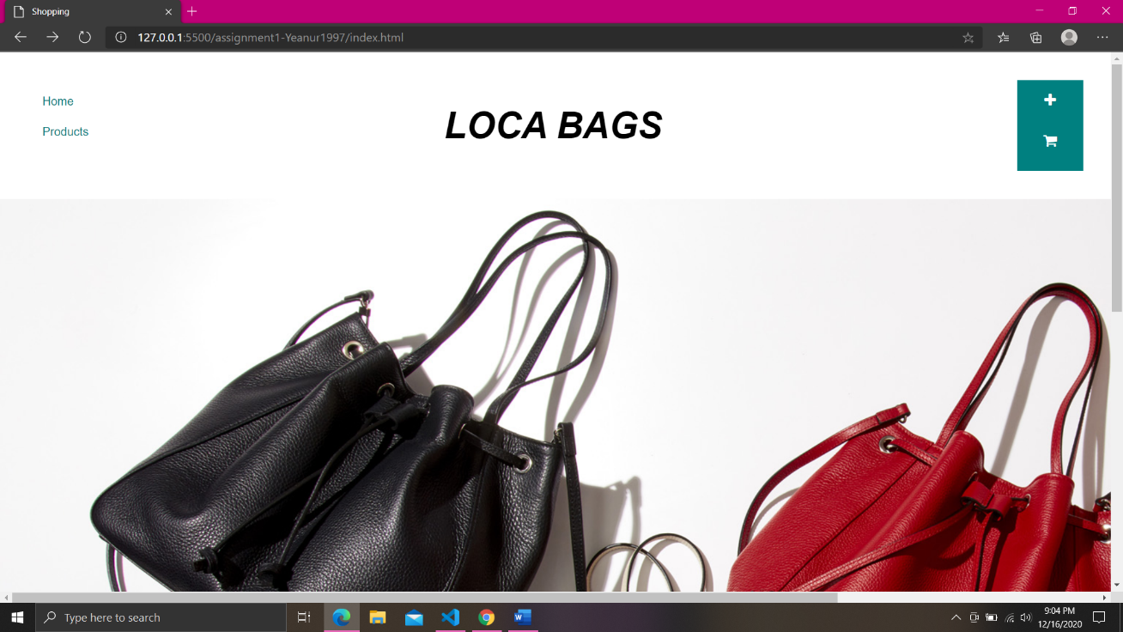**Home Page:**

**Products View Page:**

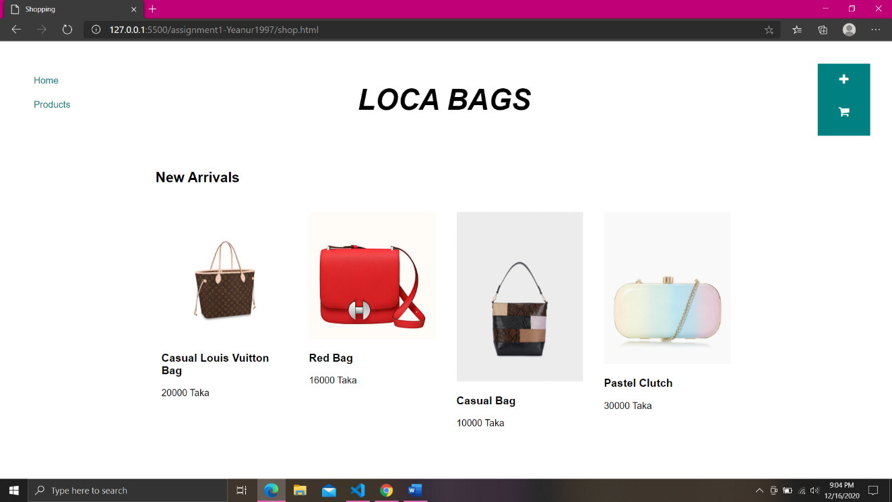

**New Product Form:**

The user needs to fill-up this product form in order to add new products to the marketplace.

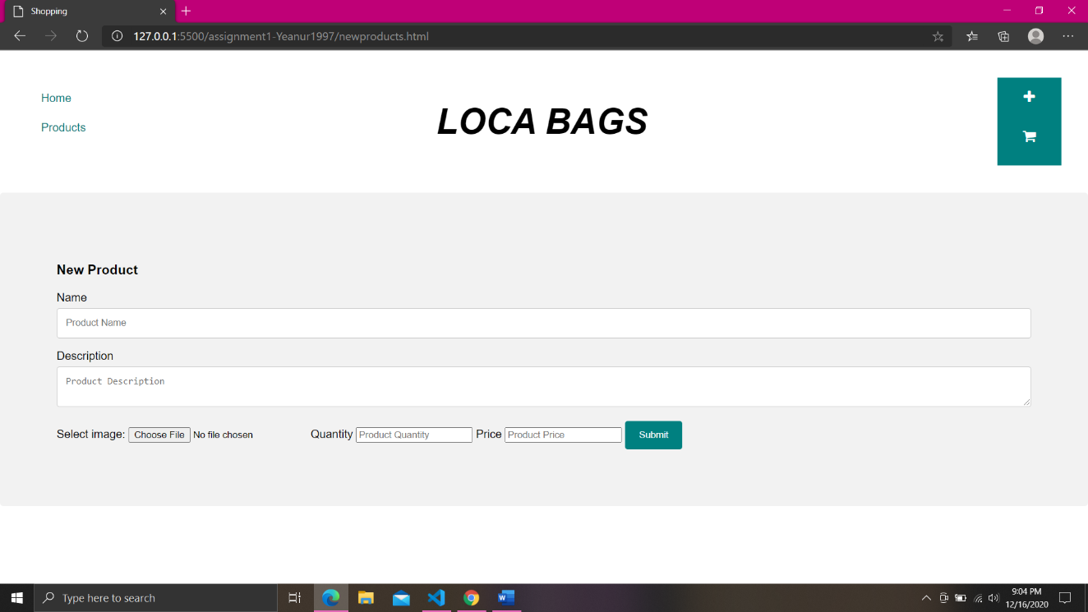

**Add to Cart Page:**

To buy items, the user needs to click add to cart button.

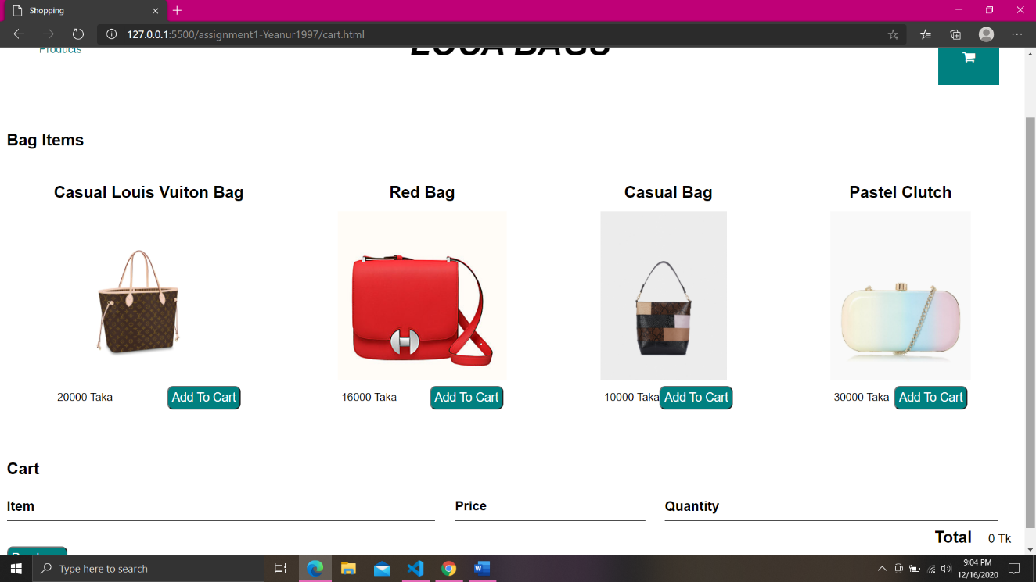

**Cart View:**

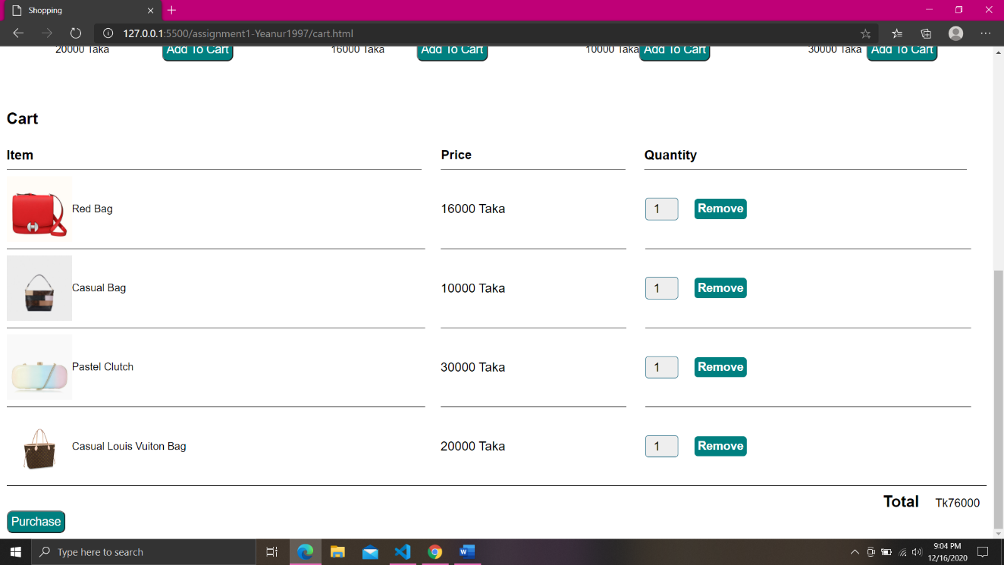After clicking on the add to cart button, the items will be added to the cart with the quantity and price. The user can also remove an item from the cart.

**Purchase Confirmation:**

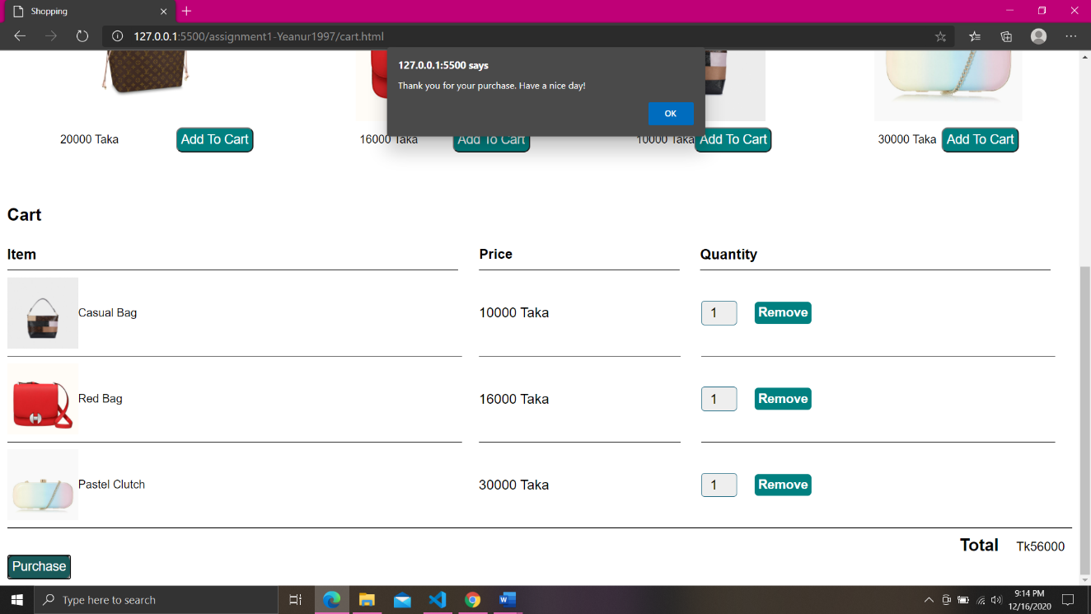After clicking on the purchase button, a purchase confirmation notification will appear.

**Note:** The pictures must be saved in the images folder and the image name must match with the IMAGE URL or the photo won’t show.